**HOSPITAL MANAGEMENT SYSTEM**

**END TERM REPORT**

**BY**

**NAME OF THE CANDIDATE(S) Roll Number(s):**

**AASHU PATEL 23**

**ROHIT SINGH 21**

**AMANDEEP 20**

**KANAV SHARMA 04**



**Department of Intelligent Systems**

**School of Computer Science Engineering**

**Lovely Professional University, Jalandhar**

**Student Declaration**

**This is to declare that this report has been written by us. No part of the report is copied from other sources. All information included from other sources had been duly acknowledged. If any part of the report is found to be copied, we are shall take full responsibility for it.**

**Signature of Student**

**Name of Student**

**Roll number: ___**

**Signature of Student**

**Name of Student**

**Roll number: ___**

**Signature of Student**

**Name of Student**

**Roll number: ___**

**Signature of Student**

**Name of Student**

**Roll number: ___**

**Place:**

**Date:**

**TABLE OF CONTENTS**

**1. Bonafied Certificate**

**2. Introduction**

2.1. Existing System

2.2. Proposed System

**3. Objectives and Goals**

**4. Description of project**

**5. Work division**

**6. Technology and framework**

**BONAFIDE CERTIFICATE**

Certified that this project report “ **HOSPITAL MANAGEMENT SYSTEM**” is the bonafide work of “ AASHU PATEL , ROHIT SINGH, AMANDEEP, KANAV SHARMA ” who carried out the project work under my supervision.

Signature of the Supervisor

Name of supervisor

Academic Designation

ID of Supervisor

Department of Supervisor

**INTRODUCTION**

**Hospitals have the responsibility of taking care of human health. They must take utmost care in providing health care services. Proper co-ordination of resources like man, machine, money and material is required to maintain superior quality in services. HOSPITAL MANAGEMENT SYSTEM (HMS) is an ideal package for integrating an entire healthcare organization.**

**Existing System:**

* **Hospitals currently use a manual system for the management and maintenance of critical information.**
* **The current system requires numerous paper forms, with data stores spread throughout the hospital.**
* **Multiple copies of the same information exist in the hospital and may lead to inconsistencies in data in various data stores.**

**Proposed System:**

* **The Hospital Management System (HMS) is designed for Any Hospital to replace their existing manual, paper based system.**
* **These services are to be provided in an efficient manner with the goal of reducing the time and resources currently required for such tasks.**

**OBJECTIVES AND GOALS**

**1. LOGIN**

**2. HOME**

**3. ABOUT**

**4. PATIENT CARE AND SERVICES**

**5. SPECIALTIES**

**6. OPD**

**7. CAREER**

**8. FEEDBACK AND QUERY**

**Description of Project**

The entire project mainly consists of 4 modules, which are...

**MODULE 1**

**LOGIN**

* By this module receptionist can login hospital website by user id and password.
* There is also a forget password page is someone forgotten his/her password they are able to create new password.

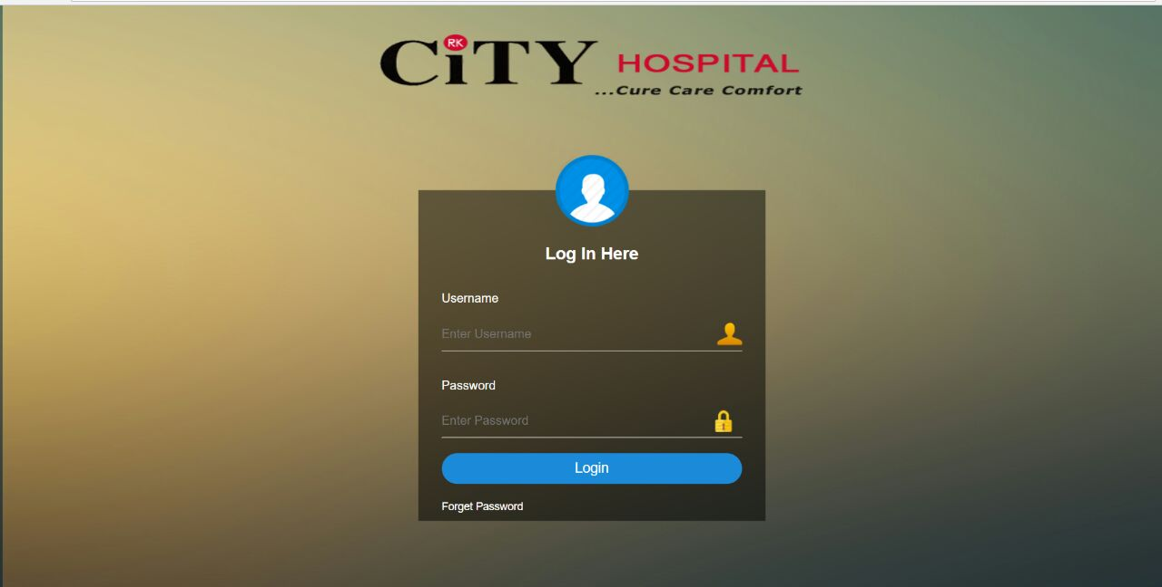

**OPD**

* In this patients are able to take an appointment from hospital for check-up and also get their report results or update from hospital.

**CAREER**

**MODULE 2**

**ABOUT**

* This module provide information of hospital. Like when it was setup, address of hospital, contact detail etc**.**
* Also about the key specialities of the hospital.

**HOME**

* Home page is a main page that contain search engine and it may also serve as a landing page.
* In homepage you find all the options to move to next page or to choose in which category you want to go.

**MODULE 3**

**PATIENT CARE AND SERVICES**

* It keeps track of all details about patient. Patient id, patient name, address, admitted date, doctor name and room no. are entered in a form.
* Also the patient emergency contact details.

**MODULE 4**

**SPECIALISTS**

This module provides information about specialist doctor available in hospital. Their name, contact detail , address and in which category they are specialist.

**FEEDBACK AND QUERY**

By this module we allow patient to give their review about treatment and if any patient or any other public member wants to know anything or any questions they can query.

**WORK DIVISION**

NAME: - **ROHIT SINGH**

REGISTRATION NO. :- **11709510**

ROLL NO. : - **21**

SECTION: - **K17TC**  GROUP: - **1**

MODULE NO. : - **1**

NAME: - **AASHU PATEL**

REGISTRATION NO. :- **11709515**

ROLL NO. : - **23**

SECTION: - **K17TC** GROUP: - **1**

MODULE NO. : - 2

NAME: - **AMANDEEP**

REGISTRATION NO. :- **11709509**

ROLL NO. : - **20**

SECTION: - **K17TC**  GROUP: - **1**

MODULE NO. : - **3**

NAME: - **KANAV SHARMA**

REGISTRATION NO. :- **11709461**

ROLL NO. : - **04**

SECTION: - **K17TC**  GROUP: - **1**

MODULE NO. : - **4**

**Technologies and Framework**

**HTML**

* **HTML FORMATTING**
* **HTML COLOR**
* **HTML TABLES**
* **HTML IMAGES, VIDEOS.**
* **HTML IFRAMES**
* **HTML LAYOUT**
* **HTML REFERENCE**

**CSS**

* **CSS BACKGROUND**
* **CSS BORDER**
* **CSS MARGIN**
* **CSS PADDING**
* **CSS IMAGE GALLERY**

**JAVA SCRIPT**

**SWOT ANALYSIS**

Hospitals have the responsibility of taking care of human health .As all know that hospitals are like our lifeline, if something happens to our body we all went to hospital or Doctor for check-up. Sometimes the diseases are enough to kill human. That is why it is very important that hospital properly maintain patient records and all his details so that they can easily contact him or his family members if something happens. Due to not proper management of records and patient sometimes it cause major problems. So, it is very important that it can properly maintain all the data.

**Advantages of Computerized Hospital Management System**

* Immediate Access of data.
* Friendly user interface.
* Time saving.
* Data can be easily insert/update/delete.
* Saving paper work.
* Give facility of different types of enquiry.
* Data are easily approachable**.**

**Homepage**

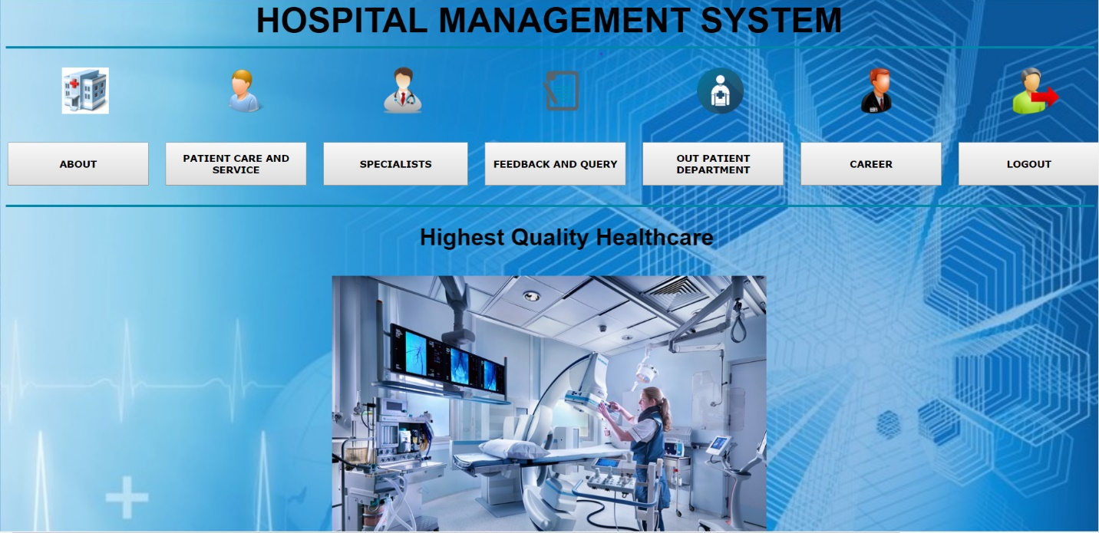

**Code:**

<!doctype html>

<html>

<head>

<title>homepage</title>

<style>

body{

background: url(55.jpg);

background-size:1540px;

}

#img{

width:40%;

}

table{

cursor:pointer;

}

button{

cursor:pointer;

font-family: sans-serif;

}

</style>

</head>

<body bgcolor="">

<CENTER> <font face="sans-serif" size="30"><b>HOSPITAL MANAGEMENT SYSTEM</b></font></CENTER>

<hr width="100%" size="3" color="#0088aa">

<table width="800" height="200">

<tr>

<th><img src="9.png" width="30%"></th>

<th><img src="6.png" width="30%"></th>

<th><img src="doctor.png" width="30%"></th>

<th><img src="8.png" width="30%"></th>

<th><img src="44.png" width="30%"></th>

<th><img src="42.png" width="30%"></th>

<th><img src="7.png" width="30%"></th>

</tr>

<tr>

<th> <a href="about.html"><button style="font-family : verdana;width:195px;height:60px;margin-right:20px"><b>ABOUT</b></button></a> </th>

<th> <a href="patient care and service.html"><button style="font-family:verdana;width:195px;height:60px;margin-right: 20px"><b>PATIENT CARE AND SERVICE</b></button></a> </th>

<th><a href="specailists.html" ><button style="font-family:verdana;width:200px;height:60px;margin-right: 20px"><b>SPECIALISTS</b></button></a> </th>

<th><a href="query2.html"><button style="font-family:verdana;width:195px;height:60px;margin-right: 20px"><b>FEEDBACK AND QUERY</b></button></a></th>

<th><a href="opd.html"><button style="font-family: verdana; width: 195px; height:60px; margin-right: 20px;"><b>OUT PATIENT DEPARTMENT</b></button></a></th>

<th><a href="career page.html"><button style="font-family: verdana; width: 195px; height:60px; margin-right: 20px;"><b>CAREER</b></button></a></th>

<th><a href="login2.html"><button style="font-family:verdana;width:195px;height:60px;margin-right: 20px"><b>LOGOUT</b></button></a></th>

</tr>

</table>

<hr width="100%" size="3" color="#0088aa">

<h1 style="font-family: algerian"><marquee><span style="font-family:sans-serif;">Highest Quality Healthcare</span></marquee></h1>

<script type = "text/javascript">

function displayNextImage() {

x = (x === images.length - 1) ? 0 : x + 1;

document.getElementById("img").src = images[x];

}

function displayPreviousImage() {

x = (x <= 0) ? images.length - 1 : x - 1;

document.getElementById("img").src = images[x];

function startTimer() {

setInterval(displayNextImage, 3000);

}var images = [], x = -1;

images[0] = "12.jpg";

images[1] = "13.jpg";

images[2] = "14.jpg";

images[3] = "15.jpg";

</script><body onload = "startTimer()">

<center><img id="img" src="startpicture.jpg" alt="city hospital"></center>

<center><button type="button" onclick="displayPreviousImage()">Previous</button>

<button type="button" onclick="displayNextImage()">Next</button>

</script><br>

<img src="50.png">

<img src="52.png">

<img src="53.png">

</body>

</html>